Preguntas Objetivo 2

Pregunta 1
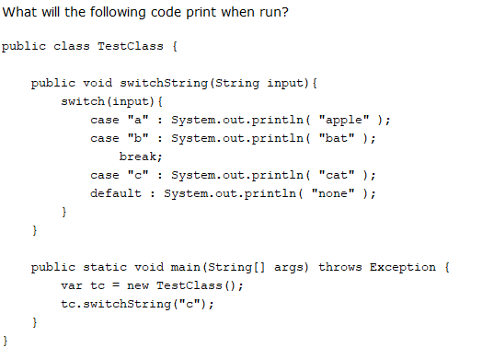
A. apple
cat
none
B. apple
cat
C. cat
none
D. cat

Pregunta 2
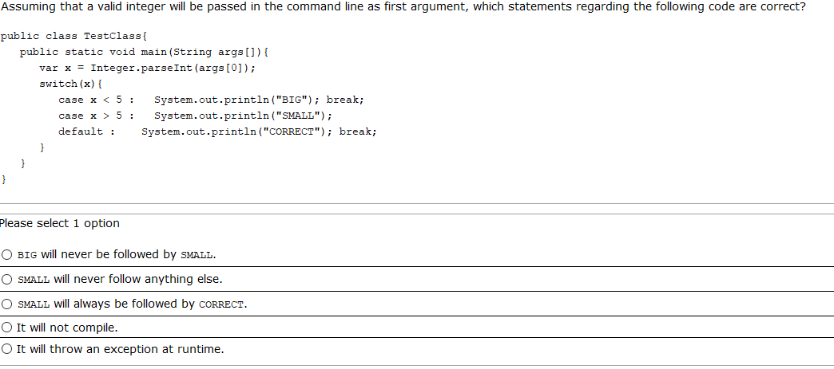
D

Pregunta 3
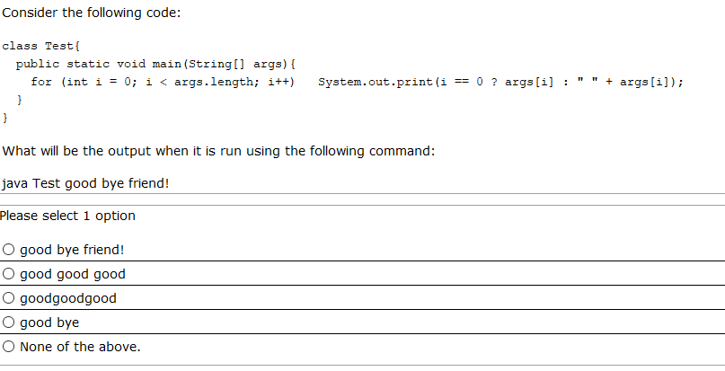

Pregunta 4
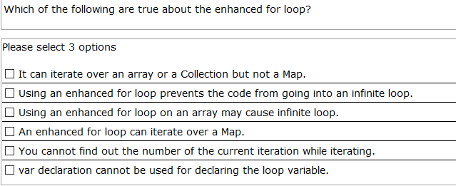

Pregunta 5
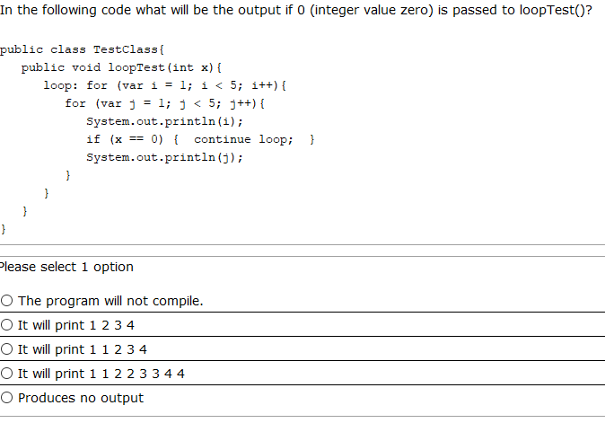

Pregunta 6
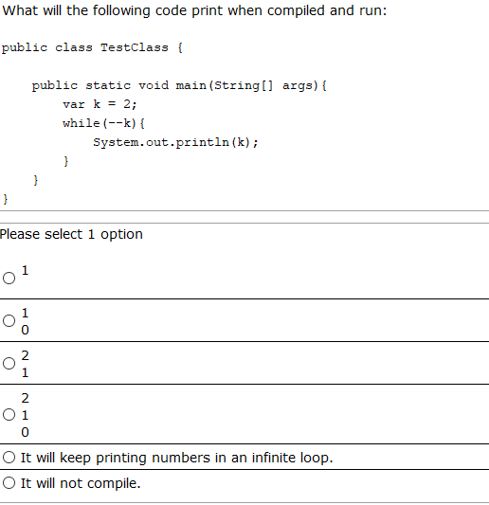

Pregunta 7
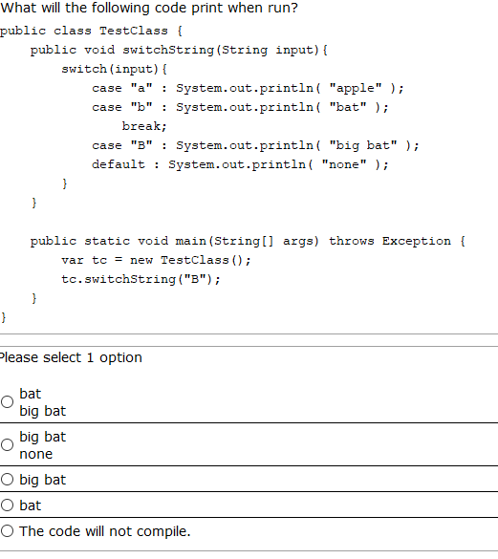

Pregunta 8
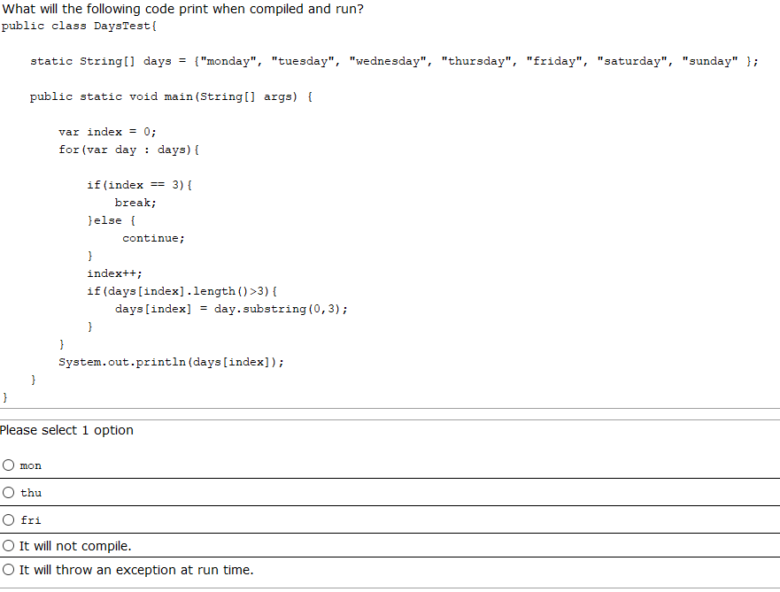
.

Pregunta 9
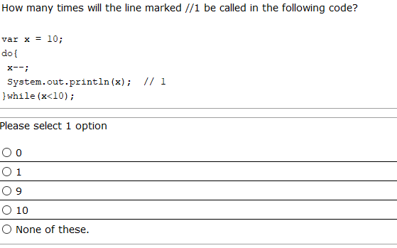

Pregunta 10
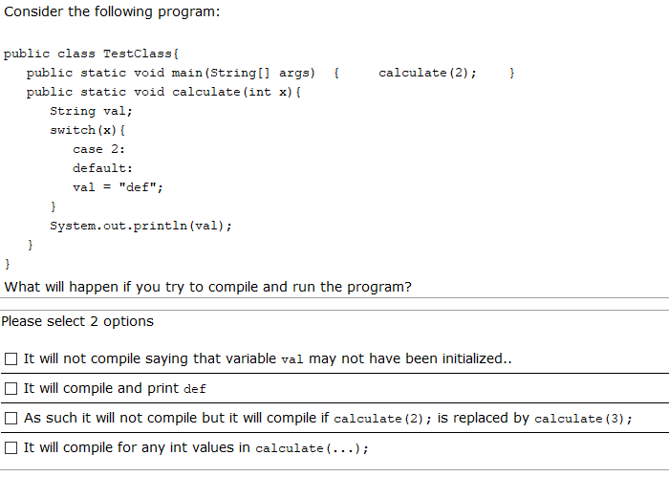

Pregunta 11
Given the following:
class A{
public void testA(){System.out.print("Is A ");}
}
class B extends A{
public void testB(){System.out.print("Is B ");}
}
class C extends B{
public void testC(){System.out.print("Is C ");}
}
And the following:
A ob=new C();
if(ob instanceof B b){
b.testB(); //line 1
}
if(ob instanceof C a){//line 2
a.testC();
} else{
ob.testA();
}
What is the result?
A.Is C
B.Is A
C.Is B Is C
D.It prints nothing
E.Compilation fails at line 1
F.Compilation fails at line 2

Pregunta 12
Given:
public static void main(String[] args){
Integer data=10;
int n=2;
switch(data/n){
case 1,3->System.out.print("low ");
case 4,5-> System.out.print("medium ");
case 6,7,9-> System.out.print("high");
}
}

What is the result?
A.medium
B.medium high
C.A runtime error is thrown.
D.Compilation error.

Pregunta 13
Given:
String cad="""
h
""";
System.out.println(switch(cad.indent(1).length()){
case 1->"simple";
case 2,3->"normal";
case 4->"optimal";
});
What is the result?
A. simple
B. normal
C. optimal
D. Compilation error

Pregunta 14
Given the following:
public class Test {
public static void main(String[] args) {
int x=100;
int a=x++;
int b=++x;
int c=x++;
//a=100, b=102, c=102
int d=(a>b)?(a<c)?a:(b<c)?b:c:b;
System.out.println(d);
}
}
What is the result?
A. 100
B. 102 <--
C. 101
D. 103
E. Compilation will fail.

Pregunta 15
public class Test {
public static void main(String[] args) {
for(var i=0;i<=5;i++) {
var res=switch(i%5) {
case 2->i*=i;
case 3->i++;
case 1,4->i--;
default->i;
};
System.out.print(res);
i++;
}
}
}

What is the result?
A. 3
B. 4
C. 04
D. -13
E. Compilation will fail

Pregunta 16
public class Test {
public static void main(String[] args){
int s=0;
int[][] nums={{2,3,8},{4,1}};
ex: for(int i=0;i<nums.length;i++){
for(int k=0;k<nums[i].length;k++){
if(nums[i][k]<s){
continue ex;
}else {
s+=nums[i][k];
}
}

}
System.out.println(s);
}

}
What is the result?
A. 0
B. 1
C. 10
D. 13
E. Compilation fails
F. The compilation is ok but prints nothing

Pregunta 17

Given:
public class TestClass{
public static void main(String args[]) {
A ab = new B();
A ac = new C();
if( ac instanceof B b1){
b1.b();
if(b1 instanceof C c1){
c1.c();
}
}else{
ac.a();
}
}
}
class A {
void a(){ System.out.print(" a "); }
}
class B extends A {
void b(){ System.out.print(" b "); }
}
class C extends B {
void c(){ System.out.print(" c "); }
}

What will be the output?
A. a
B. b
C. b c
D. b a
E. Compilation fails

